**WIRE FRAME FOR TAPIII USF CANTEEN LUNCH WE APPLICATION**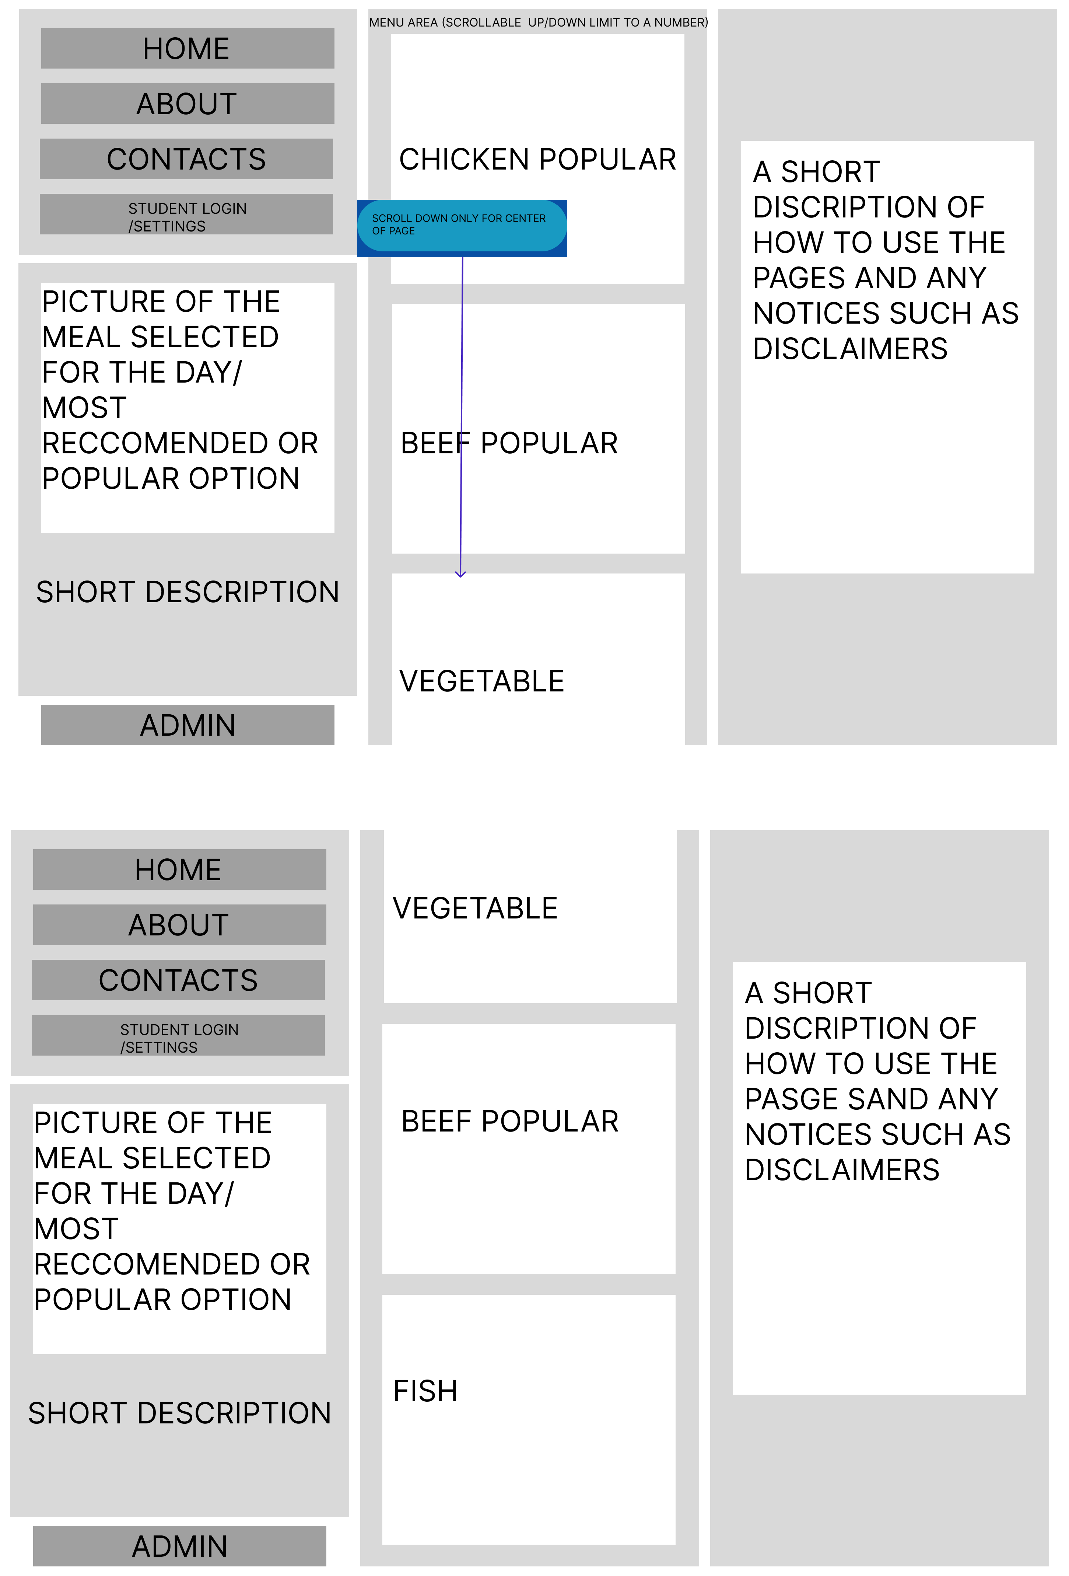

**WIRE FRAME FOR TAPIII USF CANTEEN LUNCH WE APPLICATION**

**ADMIN HOMEPAGE VEIW**

